
Two US PostCards

in Volapük

António Abreu
antabreu@yahoo.com

Abstract
In my collection of earlier postal stationary I kept two postal cards of USA written on the year 1889 in an unknown language, to the same address in Paris, France.
When I was looking to these postal cards I had the appeal to try the Internet and I put there the name of the addressee.
Following that, I came across the “volapük” language, a constructed language, created in 1879-1880 by Johann Martin Schleyer, a Roman Catholic priest in Baden, Germany.
The addressee was the leader in Paris of the “volapük” language club; the senders were speakers of “volapük” in the University of Cambridge, and in Worcester, both in Massachusetts, USA.

- Front of “ONE CENT”
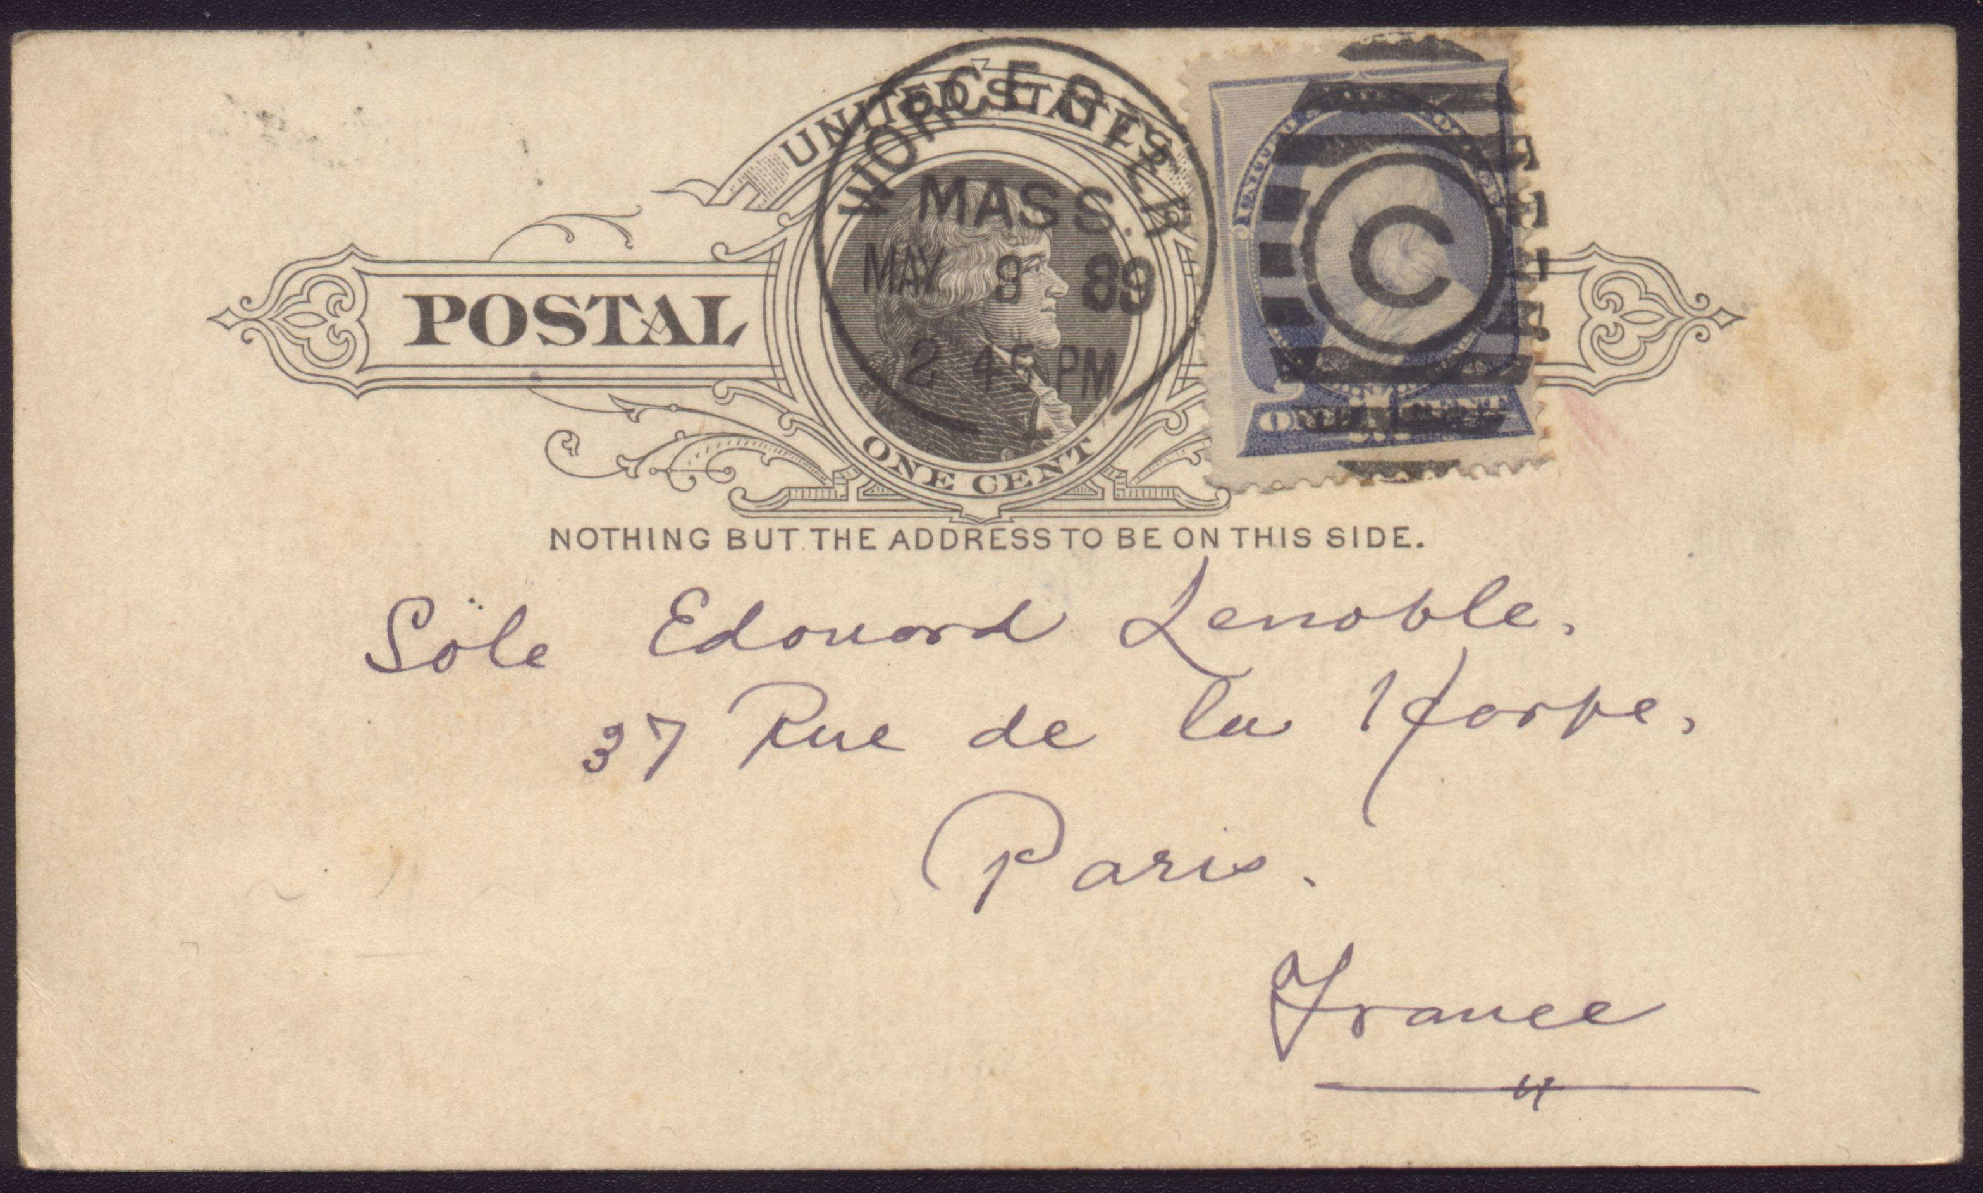

- Front of “TWO CENTS”
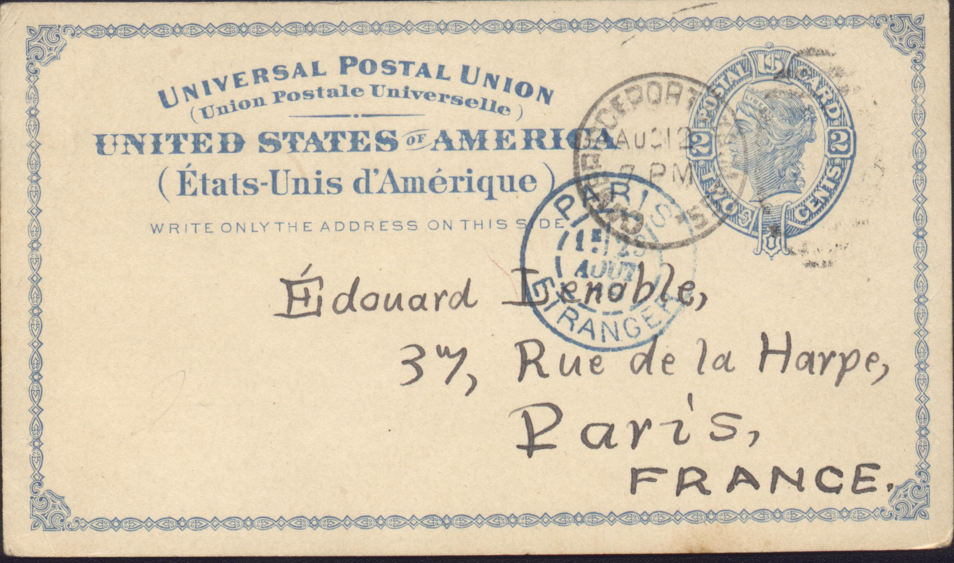

- Text
“ONE CENT” | “TWO CENTS”
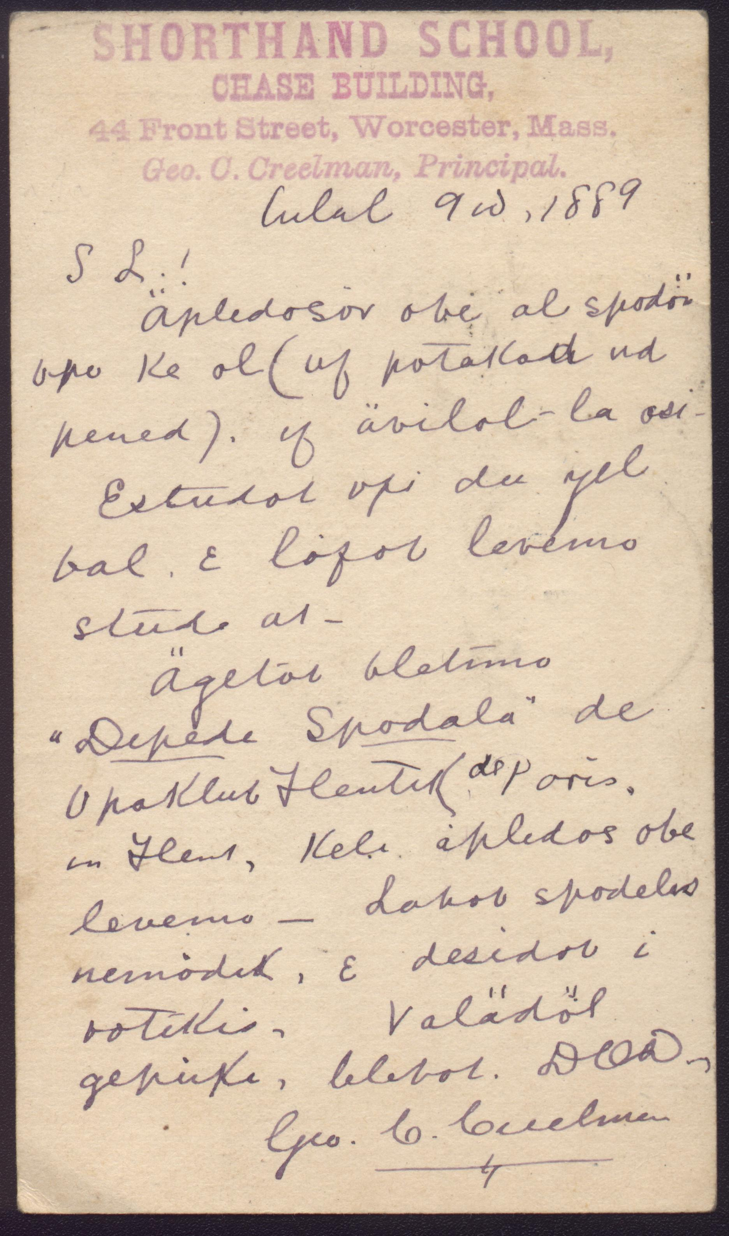 | 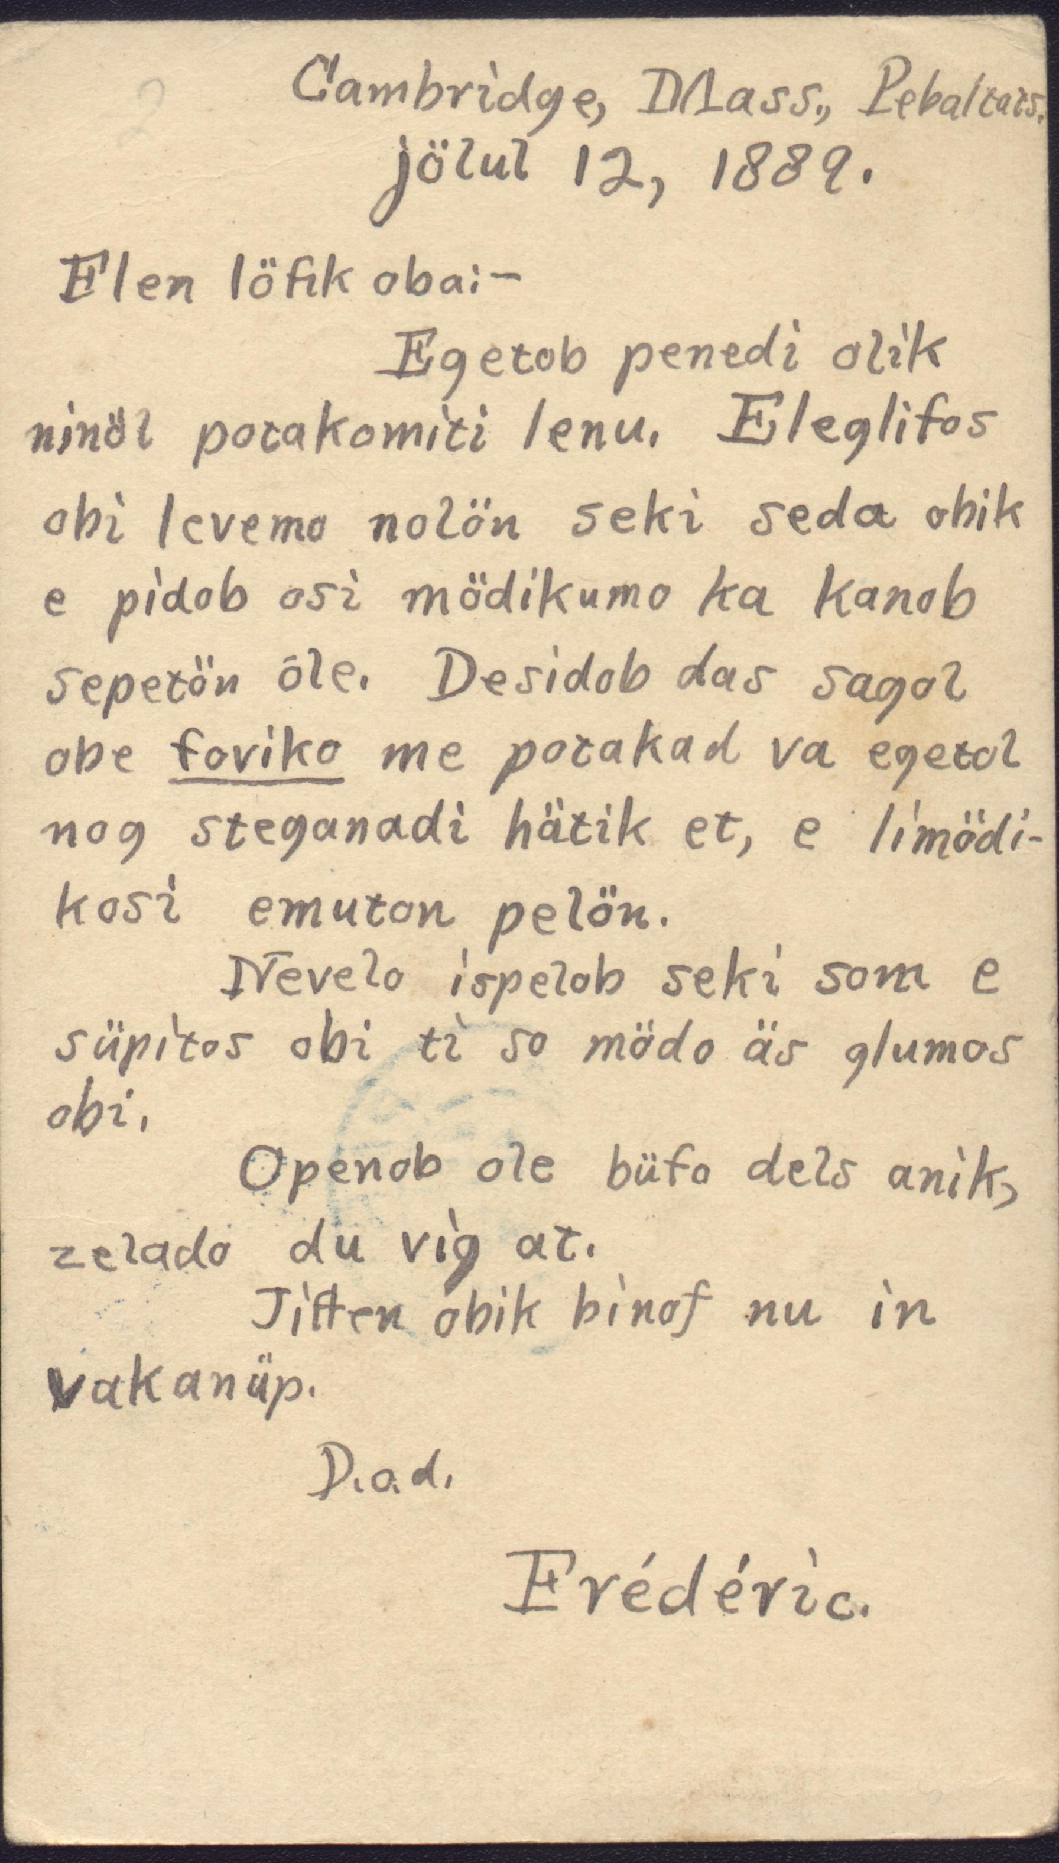

Arden R. Smith
Today at6:35 AM
(I am sending this message directly to Mr. Abreu, as well.)
The texts of the two postcards can be translated as follows:
[ONE CENT CARD]
May 9th, 1889
Dear Sir!
It would please me to correspond in Volapük with you (either postcard or letter), if you should wish it.
I have studied Volapük for one year and love this study very much.
I recently got the "Correspondent's Diploma" from the French Volapük Society of Paris, in France, which pleased me very much -- I have few correspondents, and desire others.
Awaiting a reply, I remain,
your most devoted servant,
Geo. C. Creelman
[TWO CENT CARD]
Cambridge, Mass., United States
August 12, 1889.
My dear friend --
I have just now received your letter containing the postal order. It has grieved me very much to know the consequence of my exportation and I regret it more than I can express to you. I desire that you tell me immediately by postcard whether you have yet received that hat-pin, and how much it cost.
I had never hoped for such a consequence and it surprises me nearly so much as it saddens me.
I will write you in a few days, certainly during this week.
My lady-friend is presently on vacation.
Your most devoted servant,
Frédéric.

